Secure Fingerprint Bank Locker With Image Capture

As today fingerprint based system provides high accuracy in terms of security. Also there is a high demand for integration of fingerprint matching techniques for making secure authentication systems. Therefore we have introduced this bank locker system which integrates fingerprint reader in it so as to provide a good level of security. The main goal of fingerprint bank locker with image capture project is to provide security with no manual security flaws. It is easy to use and requires no special training or equipment. This system needs fingerprint authentication while operating the bank locker as well as captures the images of person who is handling the locker and saves it in memory card which can be later viewed with card reader to the bank authorized person. The functionality of system is that it will scan the fingerprint and if it matches with registered fingerprint the bank locker opens and also captures the image of user. The system uses an atmega 328 microcontroller for this purpose. The microcontroller processes data sent by the fingerprint reader to check if user is registered, unregistered users are not allowed access. Controller operates the motors to open the locker door on encountering registered valid users.
If the fingerprint does not matches with register fingerprint of user it will shows the error message as unauthorized user and immediately saves the picture in memory card.
So, the system is very beneficial for stopping the bank locker robbery by providing security.

Block Diagram
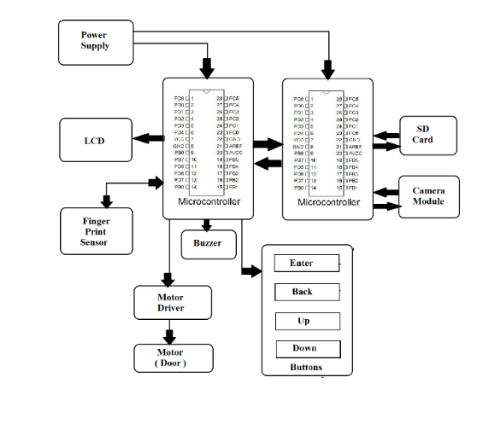

Hardware Specifications

- ATmega328P AVR MC

- Memory Card Reader
- R305 Fingerprint Sensor

- Camera

- Bank Locker Door
- Buzzer-

- LCD’s –

- Crystal Oscillator –
- Resistors –

- Capacitors –

- Transistors –
- Cables & Connectors

- Diodes –

- PCB – Buy PCB & Breadboards Online
- LED’s – Buy LED Online

- Transformer/Adapter – Buy Transformers & Adapters Online

- Push Button – Buy Buttons & Switches Online
Software Specifications

- Arduino Compiler

- MC Programming Language: C

